Findings
Ten findings from the 2011–2026 record, with evidence. Provenance: [R-AR] real, from Town of Swanzey Annual Reports 2011–2025; [R-news] local news (2026); [D] derived; [M] modeled.
Finding 1 — Operating budget has entered a high-growth regime
After a flat early-2010s (~+1%/yr, 2011–2019), the operating budget shifted to a +6–7%/yr escalation (2020–2025), rising 55% over the period to $8.94M. Growth is driven by non-discretionary costs (wages, health insurance, the ambulance contract).
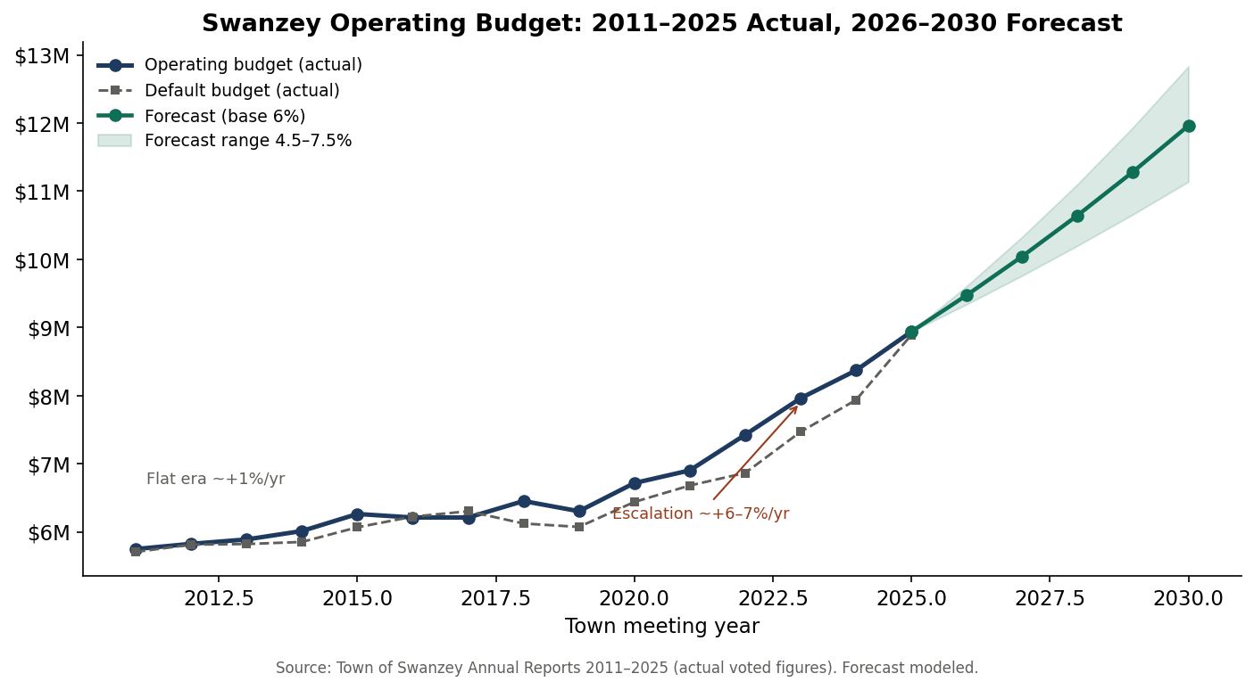
Year | Operating | Default | YoY
2011 | $5,747,885 | $5,705,757 | —
2015 | $6,262,426 | $6,067,144 | —
2020 | $6,716,500 | $6,439,109 | +6.6%
2022 | $7,425,000 | $6,864,706 | +7.6%
2024 | $8,370,000 | $7,935,699 | +5.1%
2025 | $8,939,036 | $8,891,785 | +6.8%
Finding 2 — The default-budget lever has effectively disappeared
In SB2 towns, rejecting the operating budget installs the default budget. In Swanzey the gap between proposed and default has collapsed from $560K (2022) to $47K (2025, 0.5%) — and in 2016 and 2017 the default actually exceeded the proposal. 'Vote no to save money' no longer works; the fiscal pressure valve is closed.
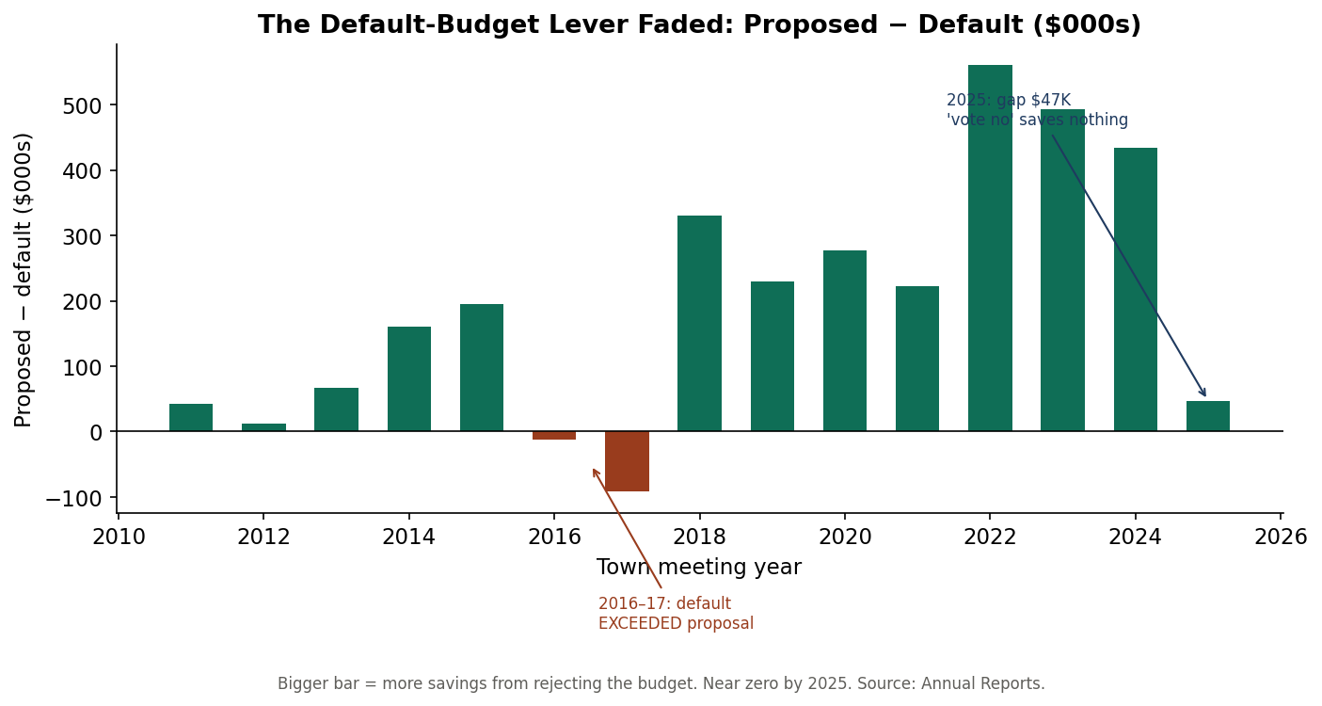
Finding 3 — Operating-budget support is eroding toward the 50% cliff
Voter approval of the operating budget has fallen from ~80% (2011–2015) to 57% (2025). On the current trend a budget failure becomes plausible within a few cycles — though, per Finding 2, the fiscal consequence would now be muted.
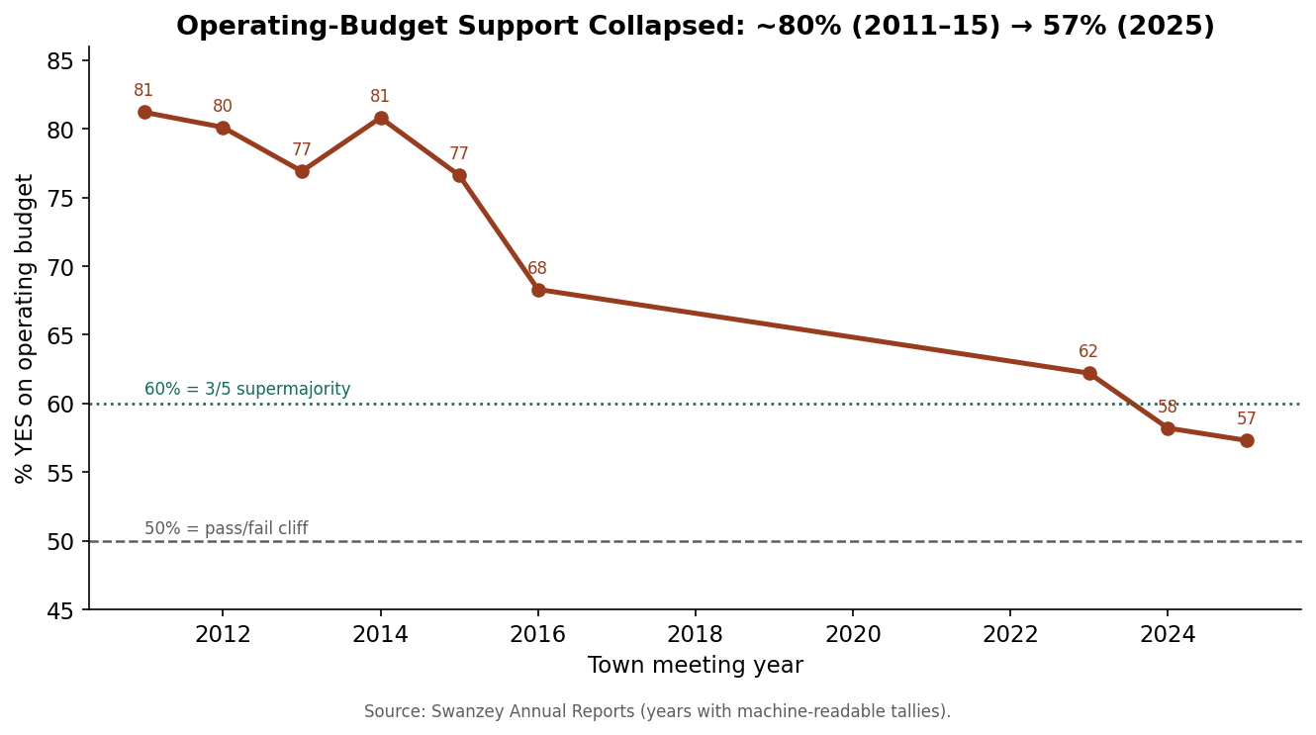
Finding 4 — Capital paralysis at the 3/5 wall
The same electorate gives tax credits ~90% and capital reserves ~78%, but gives facility bonds only 55–58% — enough for a majority, never the 3/5 a bond requires. The public works facility failed at 3/5 in both 2024 and 2026. Swanzey does not have an opposition problem; it has a supermajority-threshold problem.
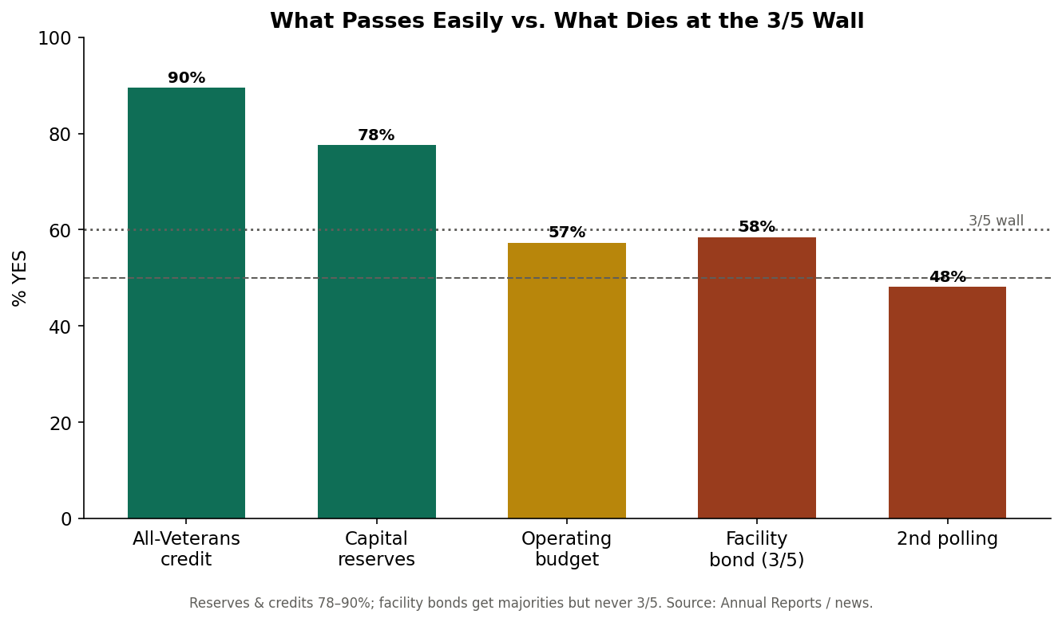
Finding 5 — The 2024 rate decline was a revaluation, not a tax cut
The total tax rate moved $26.87 (2023) → $19.06 (2024) → $20.18 (2025). The 2024 drop reflects a revaluation that raised assessed values; tax bills did not fall proportionally. Education remains ~60% of the bill and outside municipal control.
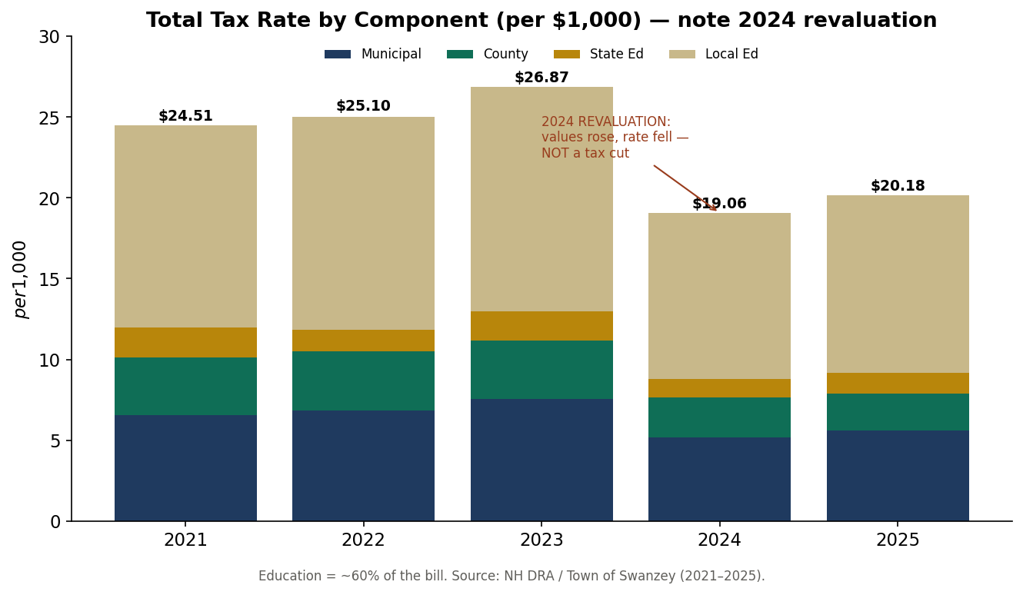
Finding 6 — Governance is being actively restructured
Question | Year | Result | Reading
Expand Select Board 3→5 | 2025 | PASS 740–653 | Want more oversight
Second polling location | 2025 | FAIL 673–727 | Don't change access
Repeal SB2 (floor meeting) | 2026 | FAIL 345–809 | Keep the all-day ballot
Notably, the Select Board recommended the SB2 repeal and the voters overruled them 2.3-to-1 — a clear board-vs-electorate divergence.
Finding 7 — Administrative instability is the master pain
Three town administrators in roughly two years: Michael Branley resigned (to Windham) in early 2025; Alex Torpey (Rethink Local) served as interim; Lori Rautiola was hired April 2025 and announced departure for July 2026 after about a year. Every other initiative restarts with each turnover; institutional memory bleeds out.
Finding 8 — Development and land use are a live legal exposure
The Avanru 74-unit senior-housing project was denied a CDBG after years of friction and is the subject of a federal lawsuit alleging the Zoning and Planning boards relied on public opposition rather than zoning criteria; the Base Hill Road storage facility has been a multi-year dispute. These chill housing and economic development and carry litigation risk.
Finding 9 — The town is absorbing a water utility
In 2025 voters authorized acquiring the West Swanzey water system (RSA 38:4, 822–553), created a West Swanzey TIF district, appropriated $3.5M and $6.4M for water infrastructure, and funded a study explicitly expecting '100% principal forgiveness' (NHDES DWSRF). This is a major new capital and ratepayer-governance obligation — and validates a reserve/SRF financing strategy.
Finding 10 — Electoral volatility is rising
Crowded selectman fields, sub-30-vote margins, ousted incumbents, and recounts (the 2026 public-works tally moved 678→681 on recount). Combined with administrator churn, continuity is the town's scarcest resource.
Provenance: [R-AR] real, from Town of Swanzey Annual Reports 2011–2025; [R-news] local news (2026); [D] derived; [M] modeled.

